### Prerequisites:

Python 3.9

Run pip install requirements.txt in order to install all relevant packages.

### Assumption:

The function will accept integers above 0

### Manual execution instructions (Linux/mac):

Navigate to the location of the test file using terminal

Run the file using the following command:

python3 main.py {arg1} {arg2} {arg3} (use spaces between args)

### Automated tests execution extraction:

After all requirements are installed, run:

Pytest path_to/test_triangle_app.py

### Test Cases:

| Name | Action | Expected | Example |
| --- | --- | --- | --- |
| Positive scalene | Input valid integers for scalene triangle | Function output is “Scalene triangle” | 1 2 3 |
| Positive Isosceles | Input valid integers for Isosceles triangle | Function output is “Isosceles triangle” | 1 1 3 |
| Positive Equilateral | Input valid integers for Equilateral triangle | Function output is “Equilateral triangle” | 3 3 3 |
| Valid large integer | Use max integer as a value | Function operates with max integer correctly | Use “9223372036854775807” as one(or more) of the values |
| Integer 0 | Use 0 as one or more of the values | Error message is printed: Invalid values | 0 1 2 |
| Negative number | Use negative numbers | Error message is printed: Invalid values | -1 1 10 |
| Missing arg | Use 2 or less arguments | Error message is printed: Missing values | 1 2 |
| Chars and Strings | Use chars or strings | Error message is printed: Invalid values | A wow 1 |
| No spaces between args | Don't put spaces between number | Error message is printed: Missing values | 112 |
| No spaces between file name and first arg | Type the args right after the filename without spaces | Error message is printed: No such file | Python filename123 |
| Special characters | Use special characters as input | Error message is printed: Invalid values | @ ! # etc |
| Floating point | Use floating point numbers | Error message is printed: Invalid values | 1.0 1.1 0.1 |

### Screenshots:

#### Pytest:

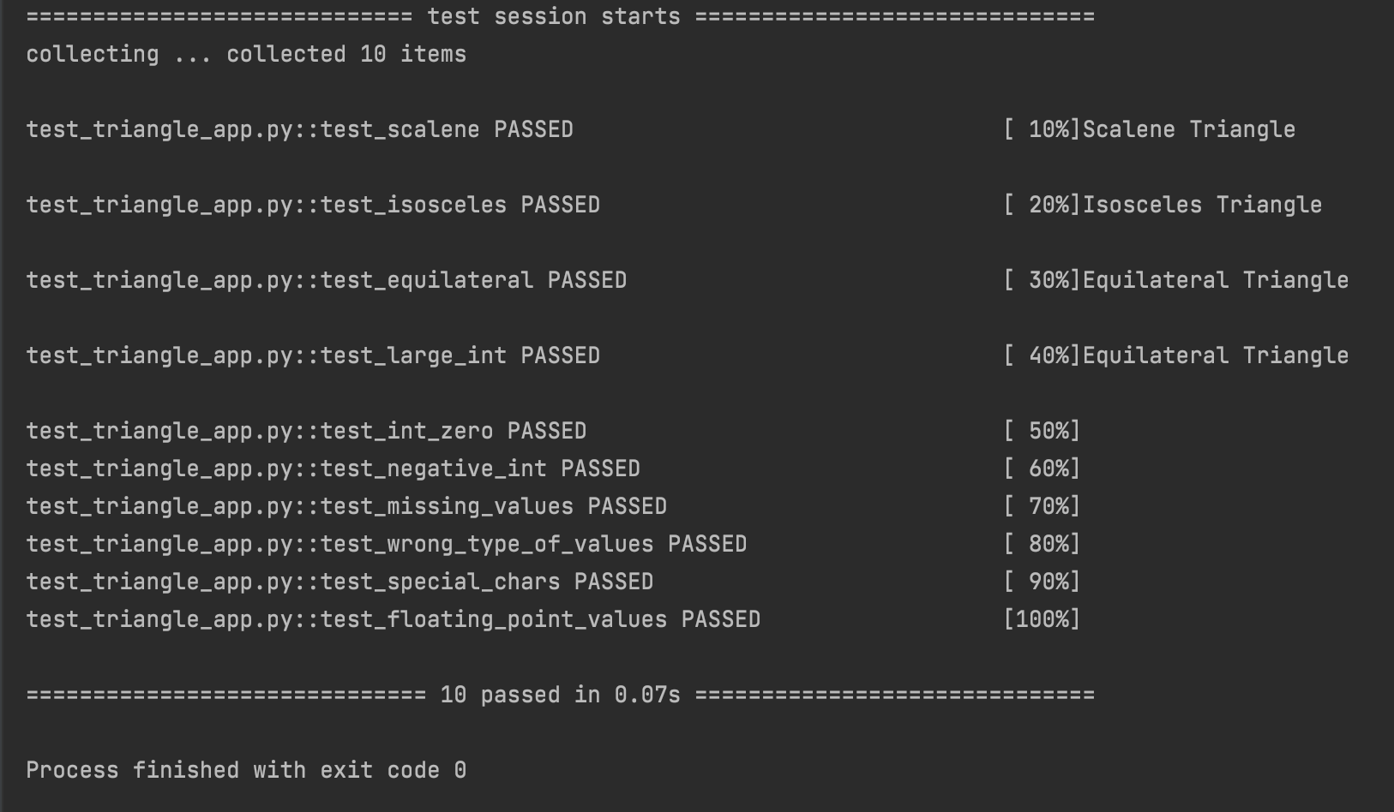

#### Running with main:

